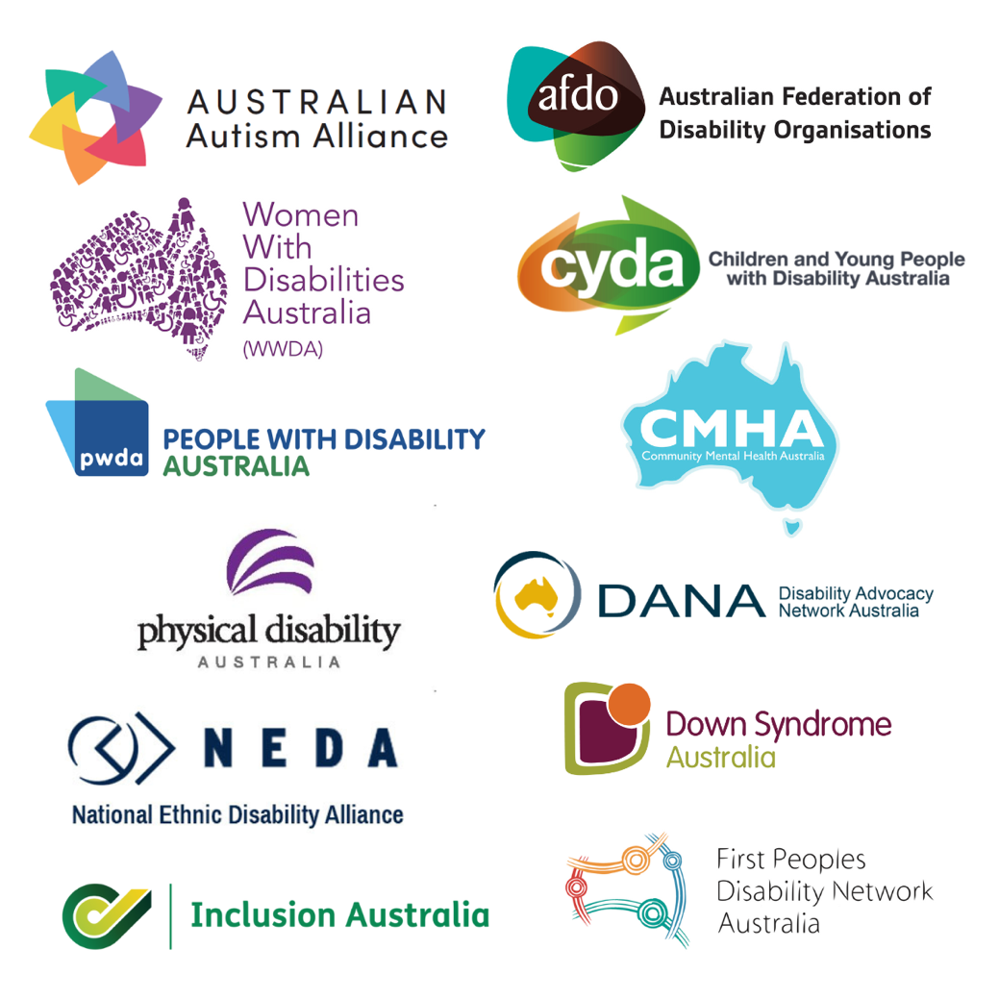

# **DRO Joint Statement on Lateral Violence in the Disability Community**

We are Australia’s Disability Representative Organisations, and our job is to protect and support the rights of people with disabilities. We are also Australians with disabilities.

Right now, our community is going through a tough time. Some people with disabilities are taking out their anger and frustration on others in the community. We say this kind of behaviour has no place here. We know how hurtful and damaging this can be because we have experienced it ourselves.

This type of behaviour is called lateral violence. Lateral violence often happens in groups like ours that are already being left out in society. Right now, this is happening a lot in the disability community, especially on social media. Social media can be a great place to find support and information, but it can also be very toxic and unsafe. Sometimes people on social media say mean, hurtful and untrue things. This is a type of violence and abuse. We say this is very wrong.

As Australia’s Disability Representative Organisations, we want to say that this kind of violence is never okay, no matter where it happens. People with disabilities should feel safe with one another while we advocate for change. We want to stay focused on the important work we need to do to improve the lives of people with disabilities.

It’s normal and helpful to have different opinions, but it’s not okay to call each other names or be mean. In a world that’s becoming more divided and harsh, we must stand up for each other’s rights.

Let’s not let anger and frustration tear us apart. Instead, let’s come together and be stronger as we work together to make important change.

**This statement has been endorsed by:**

* Australian Autism Alliance (AAA)
* Australian Federation of Disability Organisations (AFDO)
* Children and Young People with Disability Australia (CYDA)
* Community Mental Health Australia (CMHA)
* Disability Advocacy Network Australia (DANA)
* Down Syndrome Australia (DSA)
* First Peoples Disability Network Australia (FPDN)
* Inclusion Australia (IA)
* National Ethnic Disability Alliance (NEDA)
* People with Disability Australia (PWDA)
* Physical Disability Australia (PDA)
* Women With Disabilities Australia (WWDA)