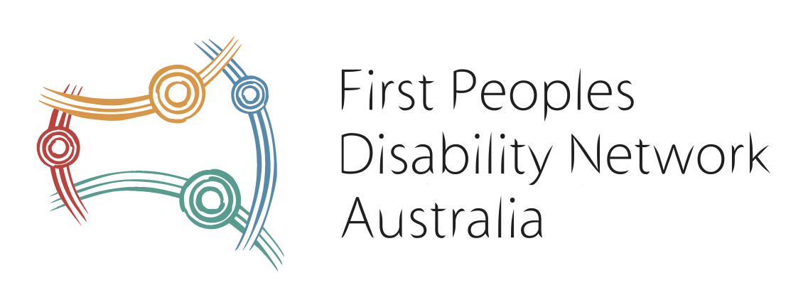

**FPDN Policy Explainer**

We welcome The National Housing and Homelessness Plan Bill 2024 (No. 2) but recommend the government adopt our recommendations within our Submission to the Senate Economics Legislation Committee.

This explainer breaks down the key issues, recommended solutions and the next steps which were highlighted in our Submission on this Bill.

**Key Issues**

* First Nations people are twice as likely to experience disability than the rest of the Australian population and its estimates that homeless rates for First Nations people are 8 times the rate for non-First Nations which is 306.8 compared with 34.9 per 10,000 population and homelessness amongst our youth (18 and younger) is estimated to be about 4 in 10 First Nations.
* First Peoples and those with a disability are disproportionately affected by inadequate housing and lived experiences of homelessness, compounded by a lack of adequate data that would allow target programs to address these needs.

**Our Recommendations**

* There must be dedicated First Nations disability representation on any and all consultation mechanisms created under the Plan.
* The National Housing Consumer Council to include a First Nations person with lived experience of disability, housing need and/or homelessness.
* The National Housing and Homelessness Plan monitoring and reporting mechanisms must include measures of significance for First Nations people with a disability, at a minimum this would include monitoring the implementation of the housing recommendations of the Disability Royal Commission.
* There must be due consideration given to the interface of ‘mainstream’, Supported Independent Living (SIL) and NDIS Housing related supports.