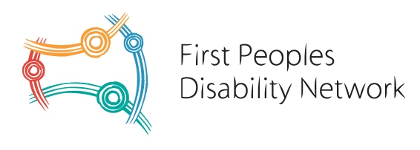

OUR VALUES

First Nations people with disability are the authorities of FPDN. Their experience as First Nations people with disability informs everything that we do. Their voices are privileged in our organisation.

We acknowledge that to ensure that we always privilege the voices of First Nations people with disability will require constant reflection. And that we as an organisation commit to always recognising when we can do better and to act accordingly.

We recognise the diversity of disability at FPDN.
And we recognise as part of this diversity some of our community members with disability communicate in different ways. Some of our community members do not use verbal communication, some of community members use sign language. Some of our community members communicate their concerns or wants or needs or frustrations in other ways. We respect the right of every First Nations person with disability to communicate in the most effective way that works for them.

We recognise that some of our community members and our colleagues may require ongoing support from FPDN as their employer or community partner. This means we commit to a workplace that is flexible in work hours. And that some of our staff and board members and community members are entitled and should expect an environment where these needs are not only recognised but are inherently understood by colleagues.

We recognise that we are in the service of others. This means our personal ego is set aside. And that we as staff of FPDN put our own needs aside for the service of others.

We also acknowledge and recognise that our work environment is unique. It is demanding and that we will encounter in our work, distressing situations. We also recognise that our work environment due to the nature of the discrimination many First Nations people with disability face, could result in us in encountering circumstances that may put our personal safety at risk. This is not the fault of our communities, this is a consequence of the disadvantage that many First Nations people with disability face. We will always endeavour to not personalise this as we are in the service of others.

FPDN as the employer commits to all staff that they will always provide a safe and supportive work environment wherever and whenever possible. And that FPDN as the employer will commit to robust workplace safety regulations and seek to review these practices on a continual basis.

We also recognise our obligations as part of the oldest continual culture on the planet. We commit to creating an environment that practices culture inherently. This will also require constant reflection and adaption. Our culture is about the collective and not the individual, this approach is what has enabled us to survive. We commit to continuing the cultural practice of collectivism. This means in practical terms that we always work as a team. We deal with conflict directly and with the support of our cultural elders. We always treat each other with respect. And critically we value everyone equally from the highest-ranking tertiary qualifications to the valuing the life of a First Nations person with disability equally. This is inherent to who we are.

As paid employees of FPDN we recognise that we are in a privileged position. And as a result, we recognise that responsibility by acting with integrity at all times. We also recognise that our board members are volunteers, as are our organisational elders. And we recognise that our founding elders Uncle Lester Bostock and Aunty Gayle Rankine were also volunteers and that their lifetime of advocacy was often done voluntarily. As staff we recognise that we are not volunteers, we get paid for our work.

We recognise that our work environment is in perpetual conflict with external systems that discriminate against First Nations people with disability. And that such a work environment is inherently challenging until the equal rights of First Nations people with disability are realised in Australia. And we always recognise this challenge requires in each of us, a compassionate and empathetic approach to our community members and to each other as colleagues.

And that as individuals in this community we commit to maintain our own cultural means of conflict resolution that gives authority to our organisation’s elders, being our board members to support us with this.

