JOINT MEDIA RELEASE: Aboriginal and legal groups horrified at secret plan to throw more children in jail.

JOINT MEDIA RELEASE

Monday 11 March 2024

A coalition of Aboriginal and legal organisations says a secret proposal to tighten NSW bail laws for children would make NSW regional communities more dangerous.

Multiple government sources have indicated off the record that a proposal to introduce punitive law and order measures – including changes to bail laws that will result in more children going to jail – may be considered as early as this week.

“Changes to bail laws that lock more children up is a short-term political stunt that won’t fix a thing on the ground in communities,” Karly Warner, CEO of Aboriginal Legal Service NSW/ACT said.
“NSW needs more youth engagement and supports because that stops crime from happening. We don’t need more short-sighted political fixes like this, that will make communities more dangerous.

“You don’t make communities safer by locking up children. Tightening bail laws to keep children locked up hasn’t worked in a single place it’s been tried. You only have to look at what’s happening in Queensland to see that it will be an unmitigated disaster.

“Meanwhile, the positive and proactive solutions that could prevent youth crime are being ignored. Regional communities should be furious that the government is not prepared to invest in services that will make them safer,” Ms Warner said.

The group has proposed an urgent three-point youth crime prevention plan that could get results quickly and without putting children in jail:

- Resources allocated for local communities to support after-school, evening and weekend activities that engage at-risk young people.
- Intensive and targeted programs and responses for at-risk children with appropriate referral services.
- Formal community partnerships between police and Aboriginal controlled services.

The coalition is made up of:

- Aboriginal Legal Service (NSW/ACT) Limited
- Aboriginal Health & Medical Research Council of NSW (AH&MRC)
- Public Interest Advocacy Centre
- First People’s Disability Network (FPDN)
- NSW Child, Family and Community Peak Aboriginal Corporation (AbSec)
- New South Wales Aboriginal Land Council (NSWALC)
- Link-Up NSW
- BlaQ Aboriginal Corporation
- The Aboriginal Culture, Heritage & Arts Association Inc (ACHAA)
- New South Wales Aboriginal Education Consultative Group Inc (AECG)
- The Shopfront Youth Legal Centre
- Redfern Legal Centre
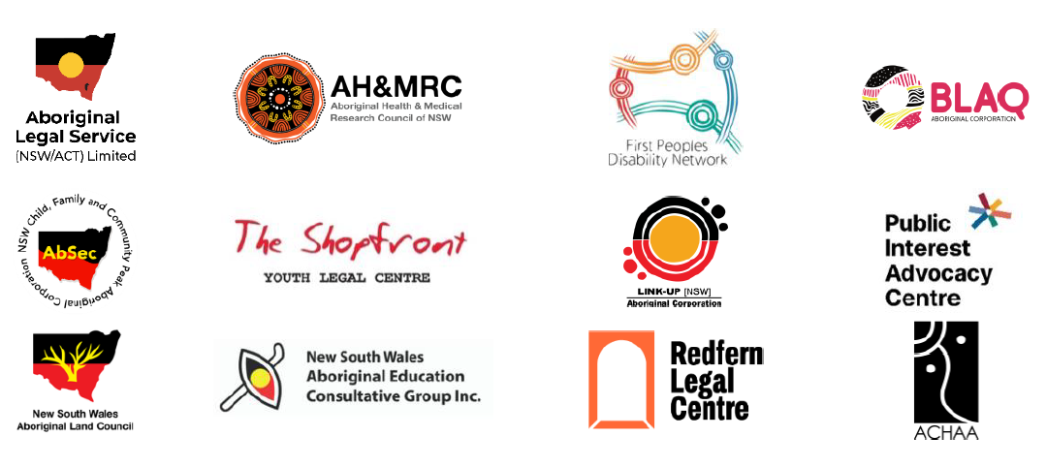
ENDS

Media contacts:

- First Peoples Disability Network: Luke Briscoe 0407773259 or email: media@fpdn.org.au

- Aboriginal Legal Service (NSW/ACT) Limited: Alyssa Robinson 0427 346 017 or Bart Denaro 0427 950 312

- Redfern Legal Centre: Camilla Pandolfini (CEO) 0493 804 073 or Lauren Gillin (media and communications) 0493 315 023

- Public Interest Advocacy Centre media: Dan Buhagiar 0478 739 280
- The Shopfront: Jane Sanders (Principal Solicitor) 0418 407 290

- NSWALC, Link-Up NSW, FPDN, BlaQ, AH&MRC, AECG, AbSec, ACHAA: 02 9689 4444 or caposecretariat@alc.org.au
Bottom of Form

